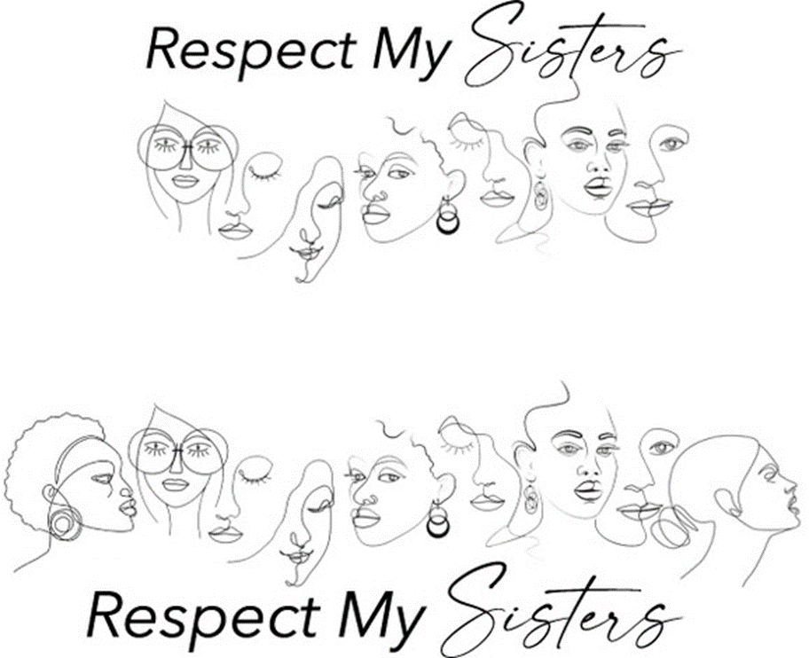

Royce and Nedra Boyles founded **Respect My Sisters** in 2022.

Nedra’s miraculous journey from the inner city of Chicago to becoming an educated woman, loving and supportive mother and wife, successful real estate broker and college administrator was influenced by a great woman - her grandmother.

Royce’s appreciation and respect for women has been a long developmental process made possible by many factors, including a desire to advance racial, gender and social justice reform.

The couple believed that a comprehensive women’s movement was needed to address women’s advocacy in several areas.

Defying the odds of being in meager circumstances, Ruth Shiner, encouraged her granddaughter Nedra, to learn, achieve and pursue education.

The inner city is a place, but also a state of mind.

Grandmother Ruth held visions of a world in which a Black girl of the 1960’s had a chance to be treated with fairness and dignity individually, educationally and occupationally.

Nedra obtained a master’s degree in business from the University of Wisconsin – Whitewater and has begun PhD studies.

Sadly, many girls do not have a Ruth Shiner to open their minds to dreams, choices and possibilities.

**Respect My Sisters** was founded to do that – and more.

Royce is from a small Wisconsin town, working-class family that placed little value on education – one of five children, only he and his sister gained so much as a high school diploma. Women were not viewed as equals in the world of his youth.

Ignorance is a state of mind.

He managed to begin college studies and have a radio and television broadcasting career before alcoholism obliterated them both.

At the time of co-founding **Respect My Sisters** with his wife Nedra, Boyles surpassed 42 years of continuous sobriety, had secured a Bachelor of Arts degree and authored three books about Green Bay Packers coach Vince Lombardi.

Taking very different roads to the same destination, the Boyles’ arrived together at a location in hopes of making the world a better place for women.

That place is **Respect My Sisters** - which is more than a state of mind.